Hi All,

Below are the steps to get a proper installation of Visual Studio 2013 on user machine.

Go To IT Service portal: <https://rb-servicecatalog.apps.intranet.bosch.com/RequestCenter/website/Grunt/application/category.html?id=29>

**Click on Desktop Software → ADD/Remove Software**

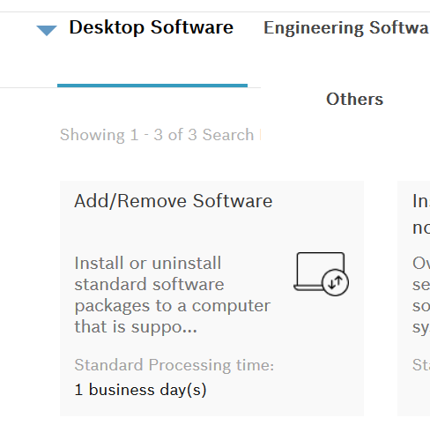

After clicking on Order tab → Computer Selection, Select the below software to install



Once it is installed run the below highlighted packages on user machine.

\\festorage02.ecn.etasgroup.com\csw\_Standard_Software\Development\EHI-TFS2013Client#FREE_LIC\iCAT

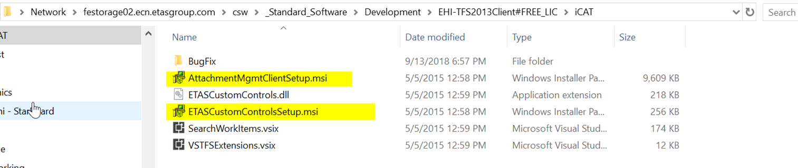

Then go to C:\ProgramData\Microsoft\Team Foundation\Work Item Tracking\Custom Controls\12.0 path in user machine and verify if highlighted files are present in this folder.

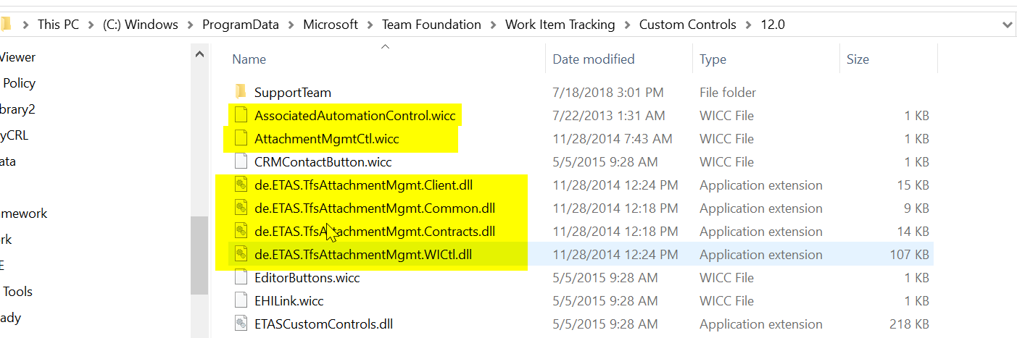

If not present copy these files from C:\ProgramData\Microsoft\Team Foundation\Work Item Tracking\Custom Controls\10.0 to 12.0 folder

Then copy and replace the attached file “TFSUtilities.dll.config” on the folder C:\ProgramData\Microsoft\Team Foundation\Work Item Tracking\Custom Controls\12.0

Best regards,   
  
**Elfrida D Mello  
RBEI/BSI3**  
Tel. +91 80 6799-2625